**ETHNUS**

**AMAZON WEB SERVICES**

**FACE-DETECTION APP ON AWS**

**Name: Manojkumar.p**

**Email-id:manojkumarp308@gmail.com**

**Phone no:9047056728**

**1.AWS:**

a. Aws login screen with username

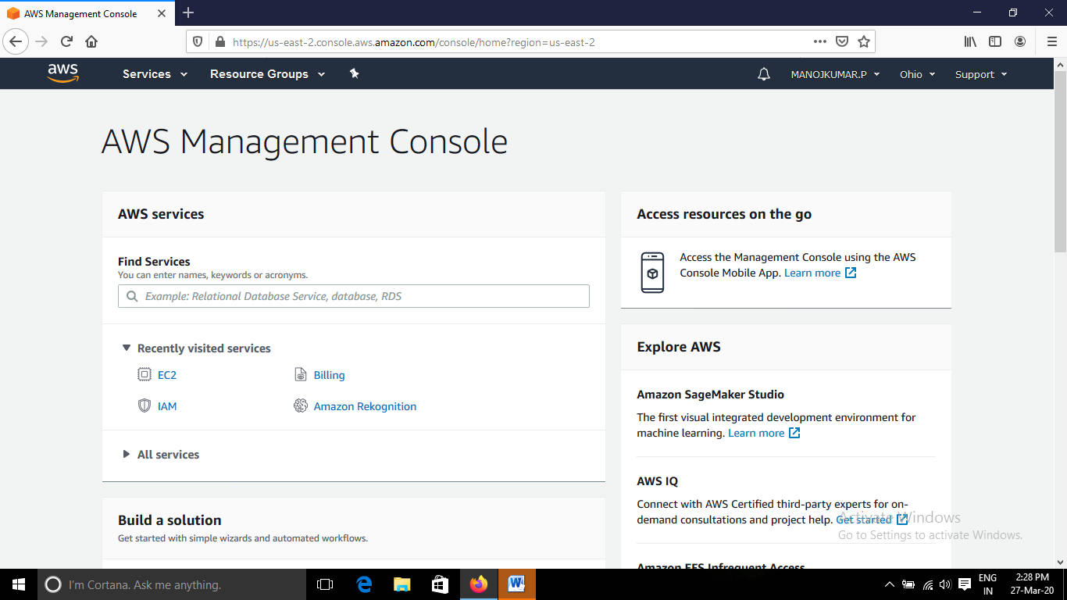

b. Ec2 Dashboard

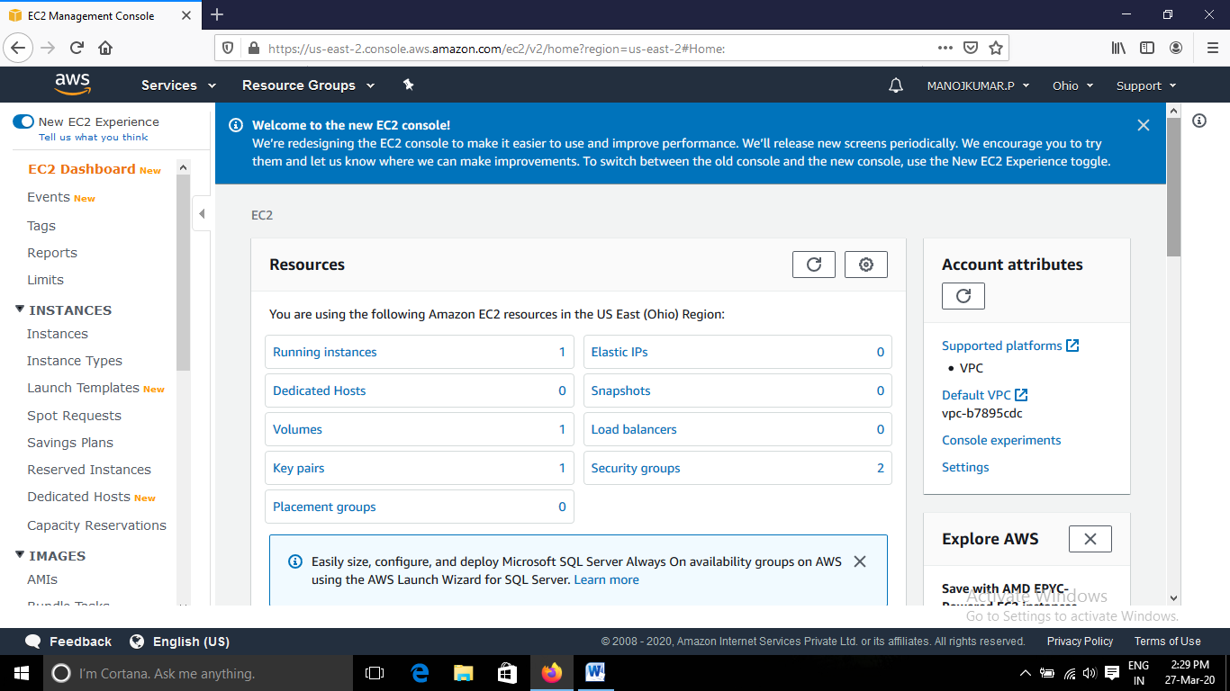

c. S3 Dashboard

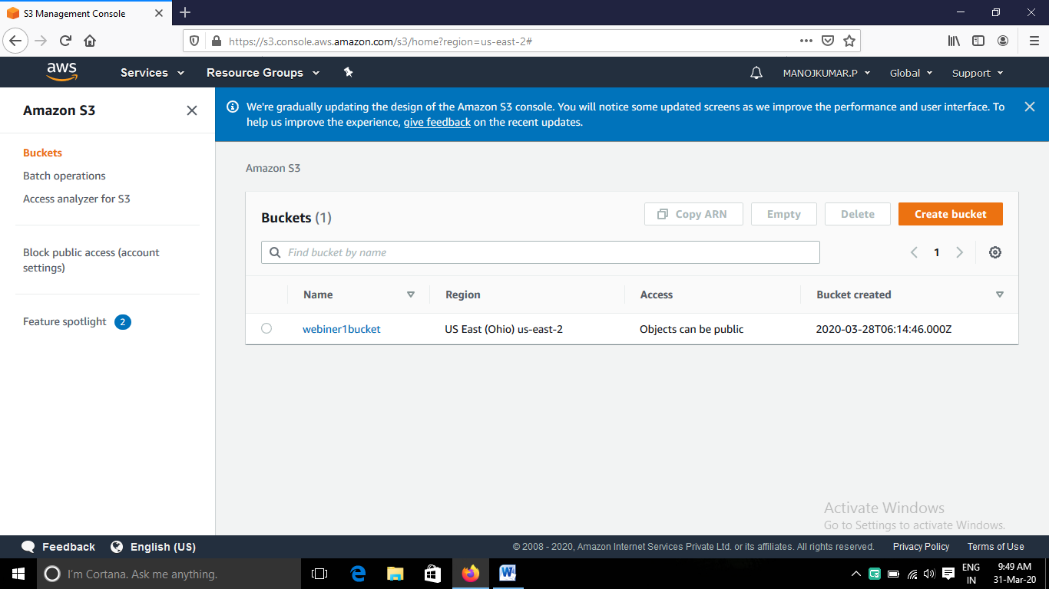

d. Rekognition Dashboard

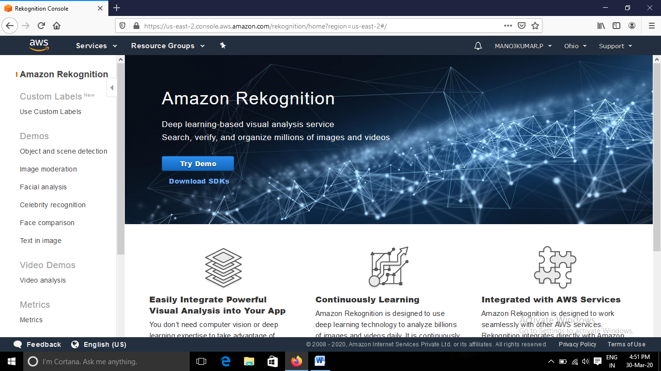

2.Ec2

a. Choosing an AMI

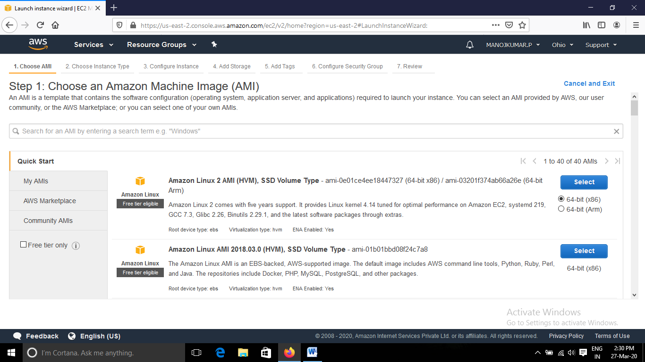

b. Choosing an instance type

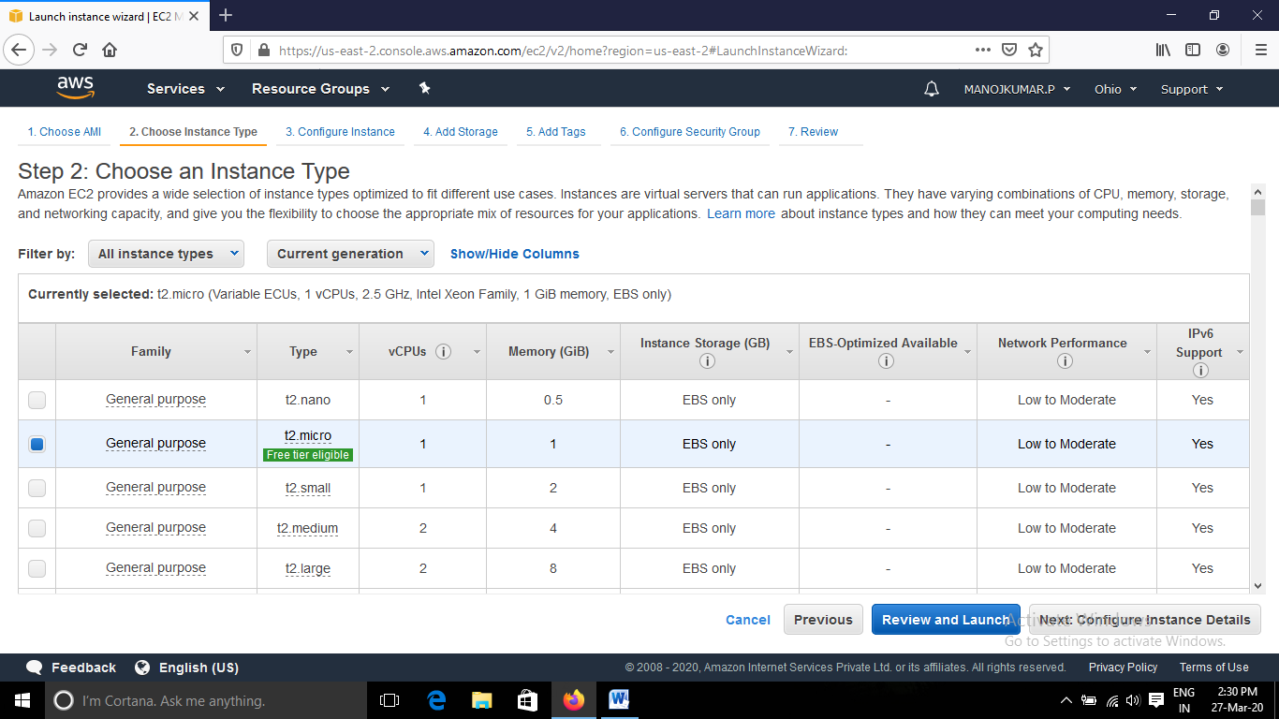

c. Adding storage

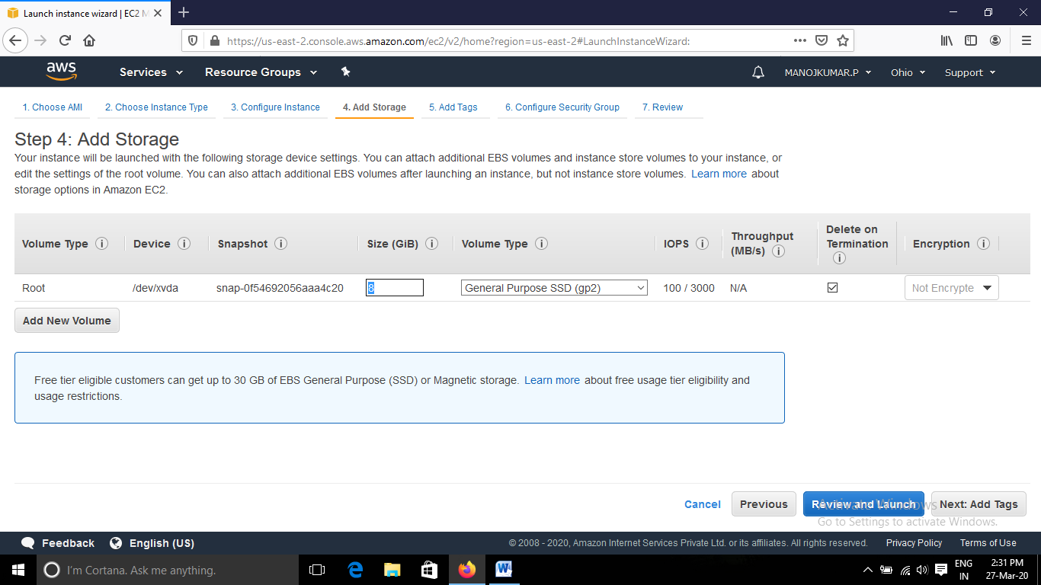

d. Configuring security group

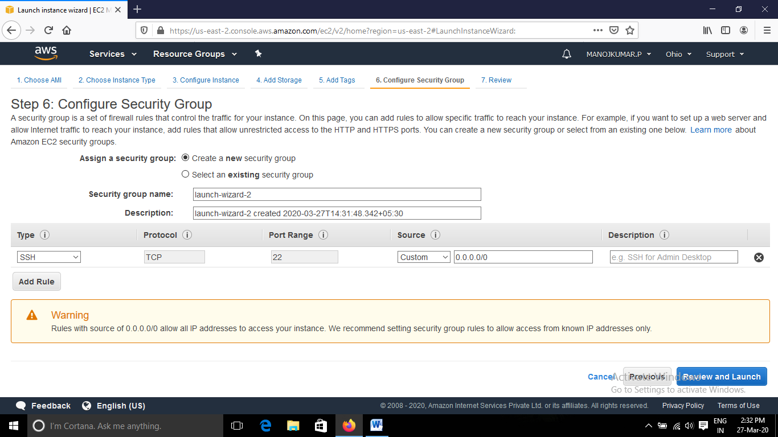

e. Keypair download

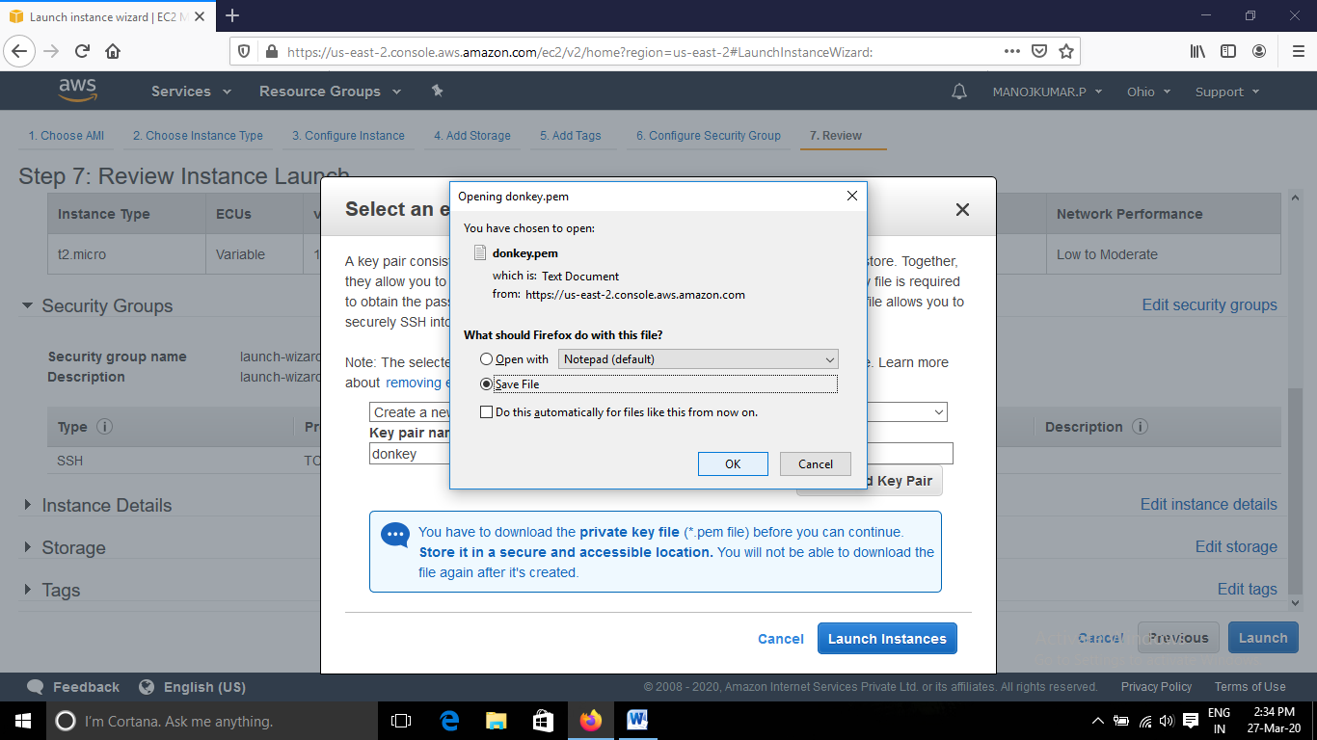

f. Puttygen conversion from pem to ppk

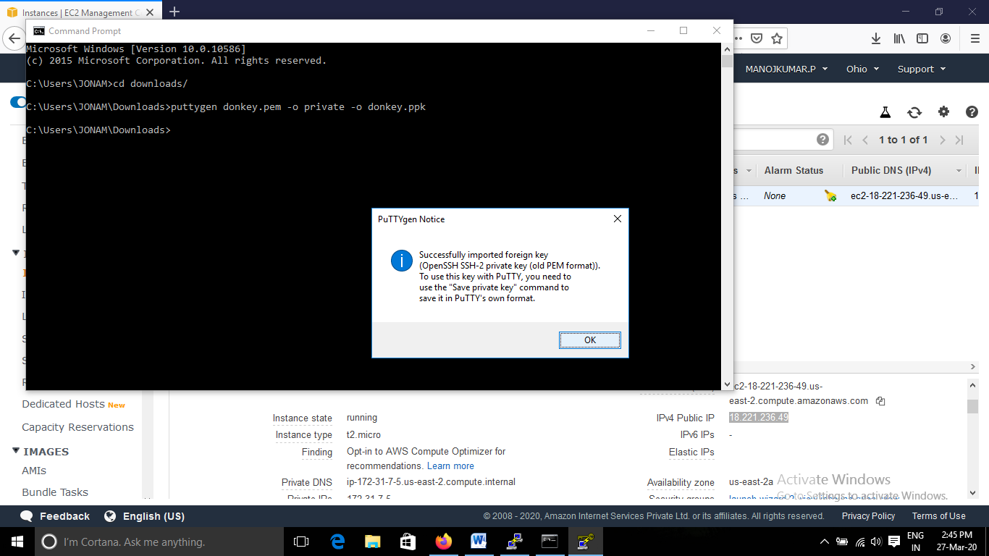

g. Logged in Ec2 black screen

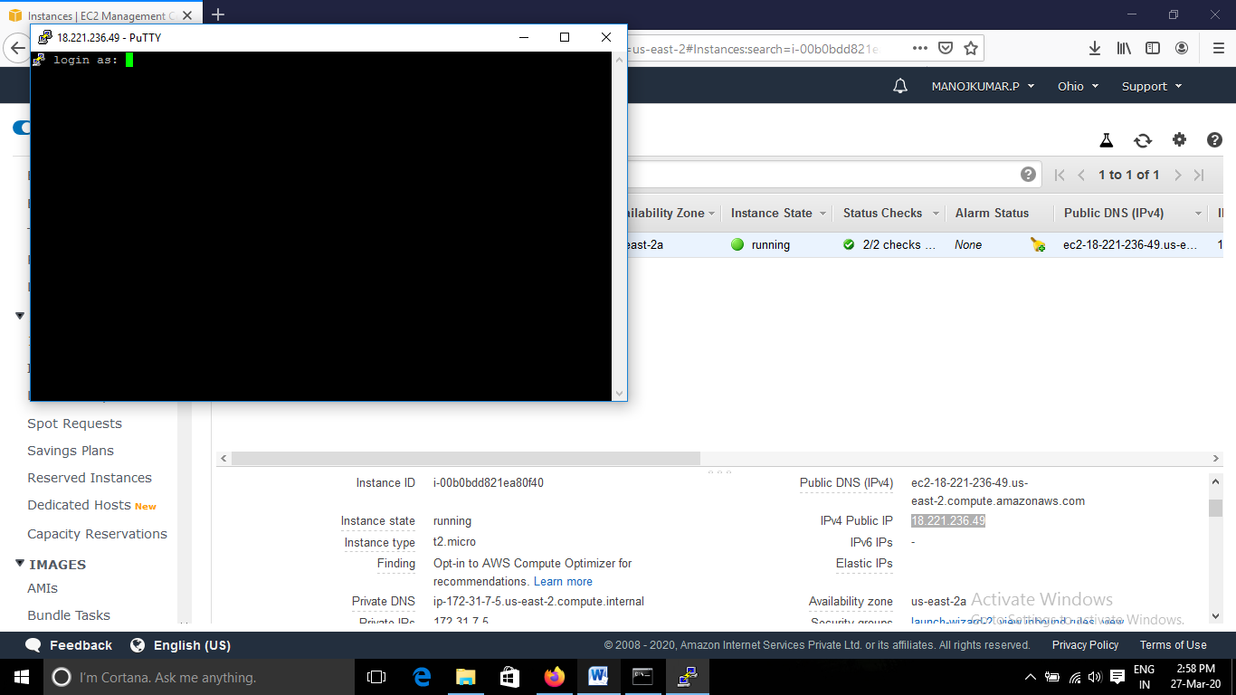

**3.S3**

a. Creating bucket

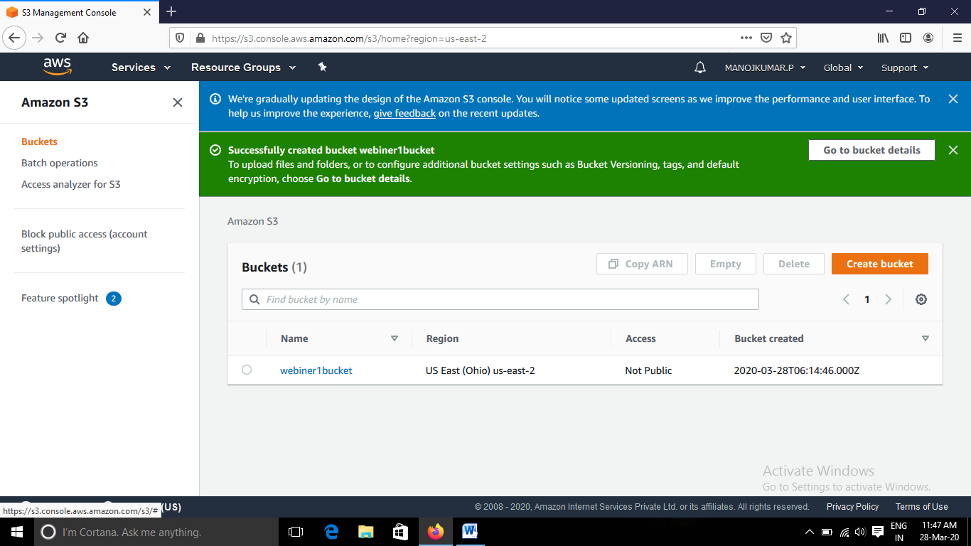

b. Uploading an object

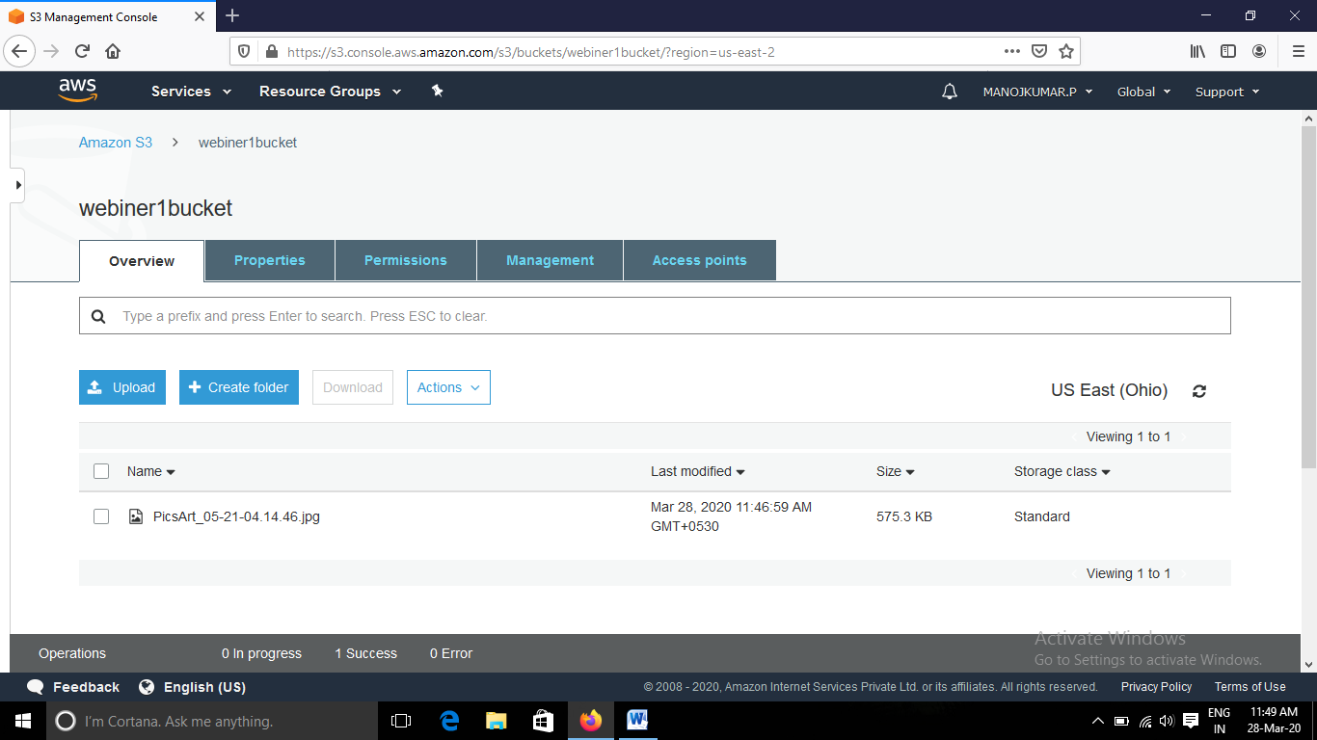

c. Enabling static website

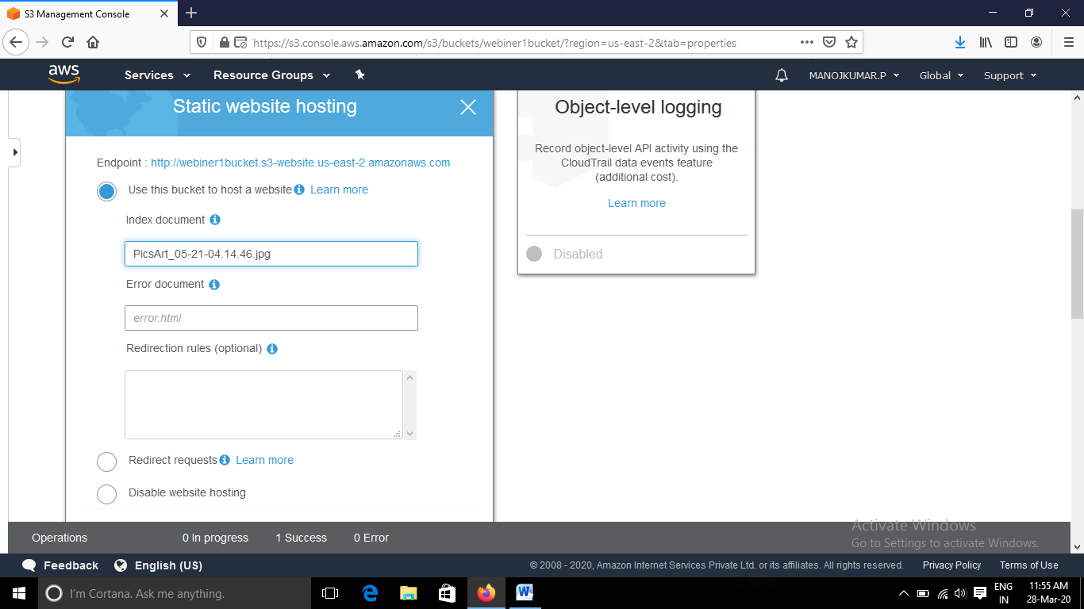

d. Making the object public

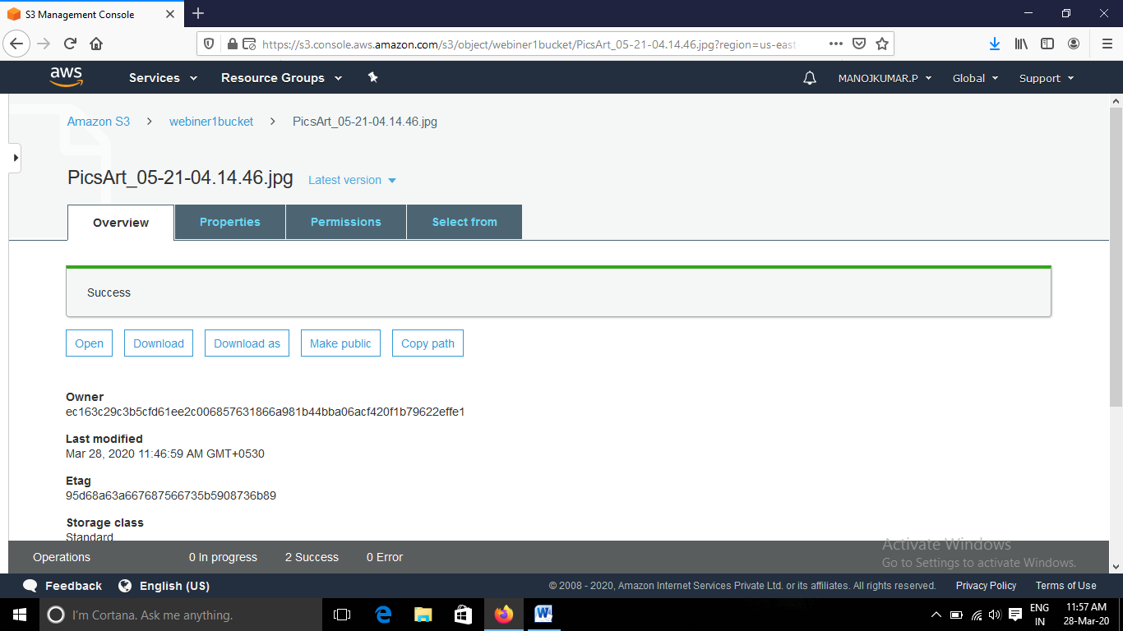

e. Checking the S3 link on the browser

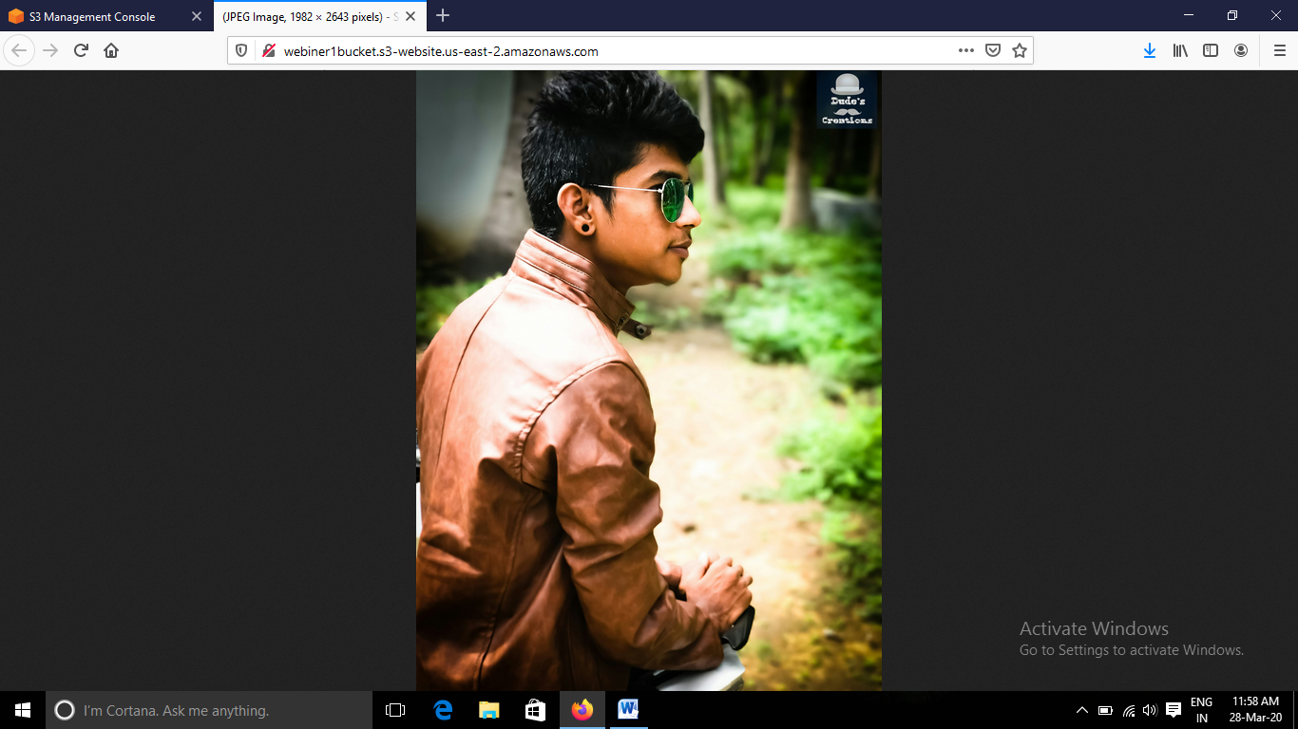

**4. Rekognition**

a. Face detect

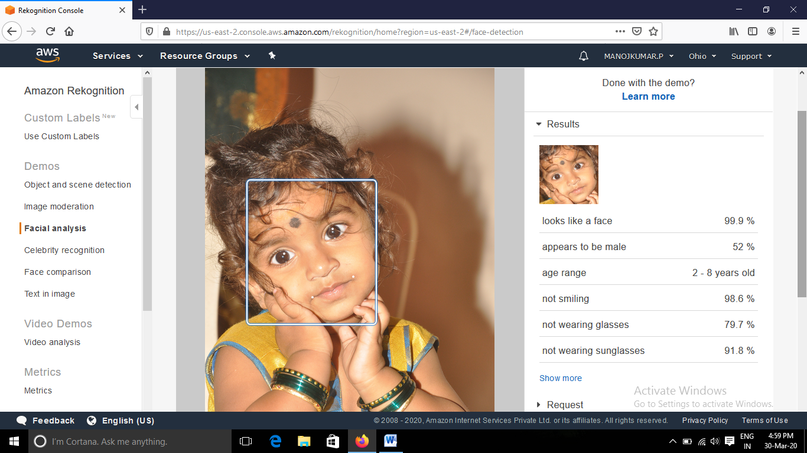

b. Face compare

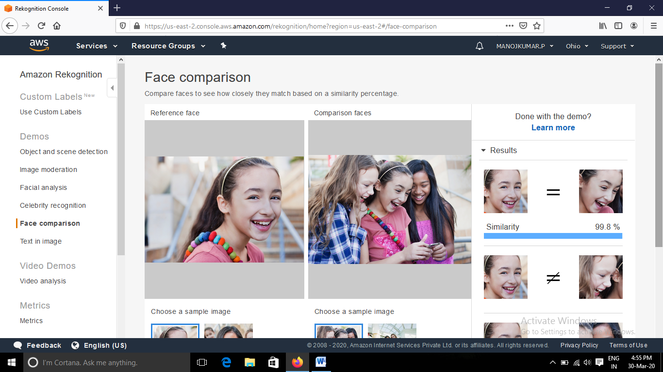

c. Celebrity recognition

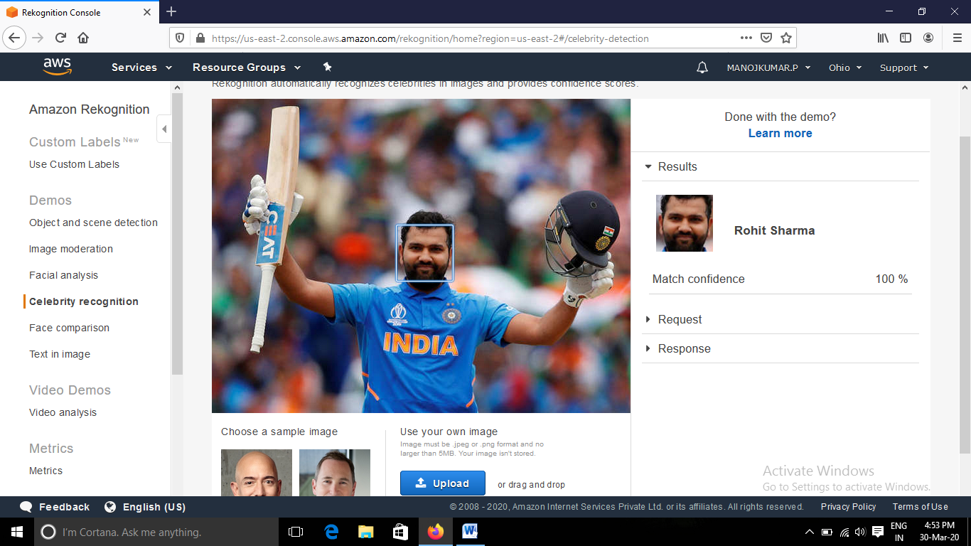

d. Text in image

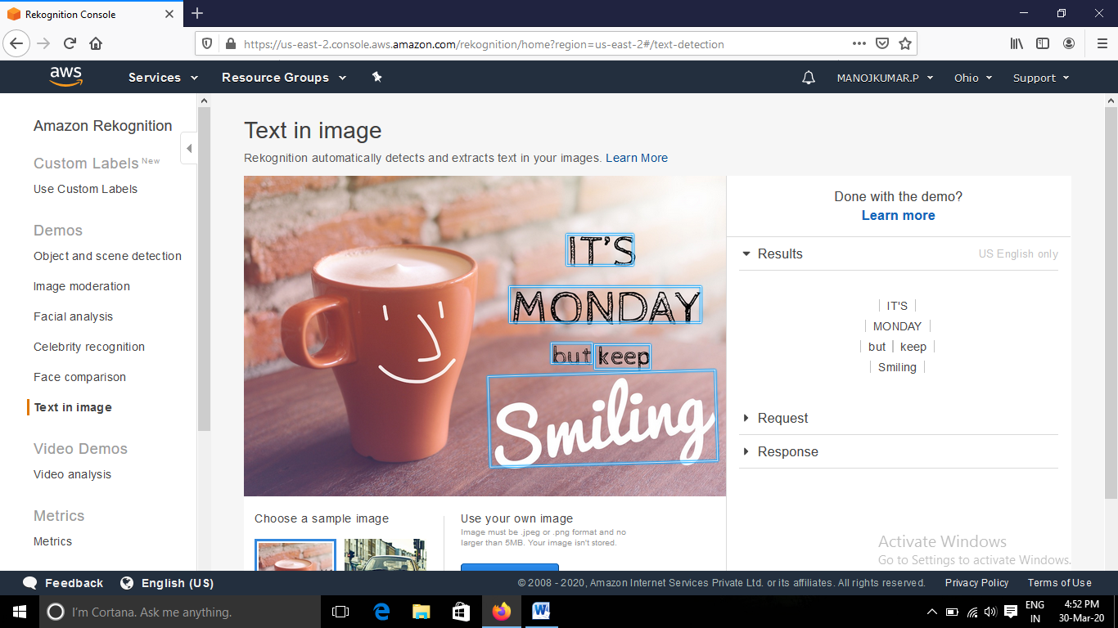

**5. Ec2 & S3**

a. installing php

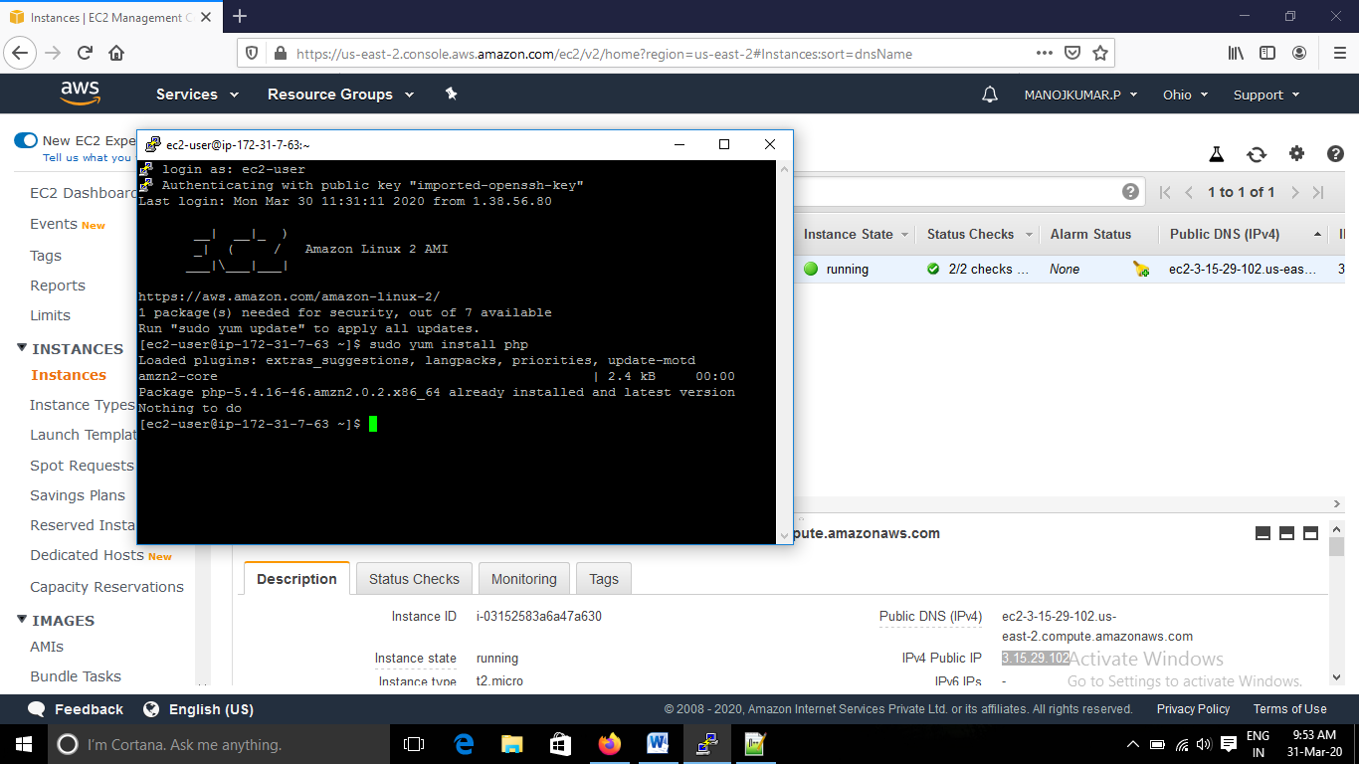

b. installing aws-sdk

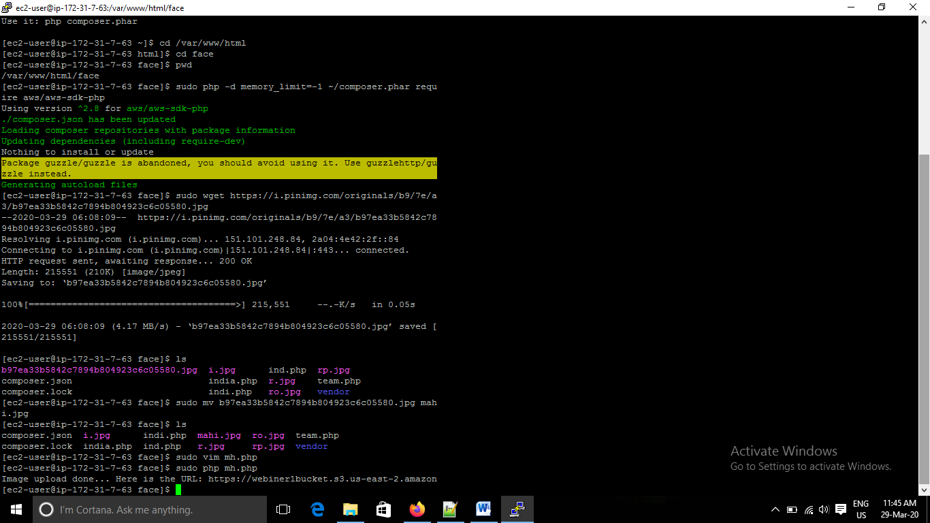

c. mh.php file code ( I have sudo vim mh.php)

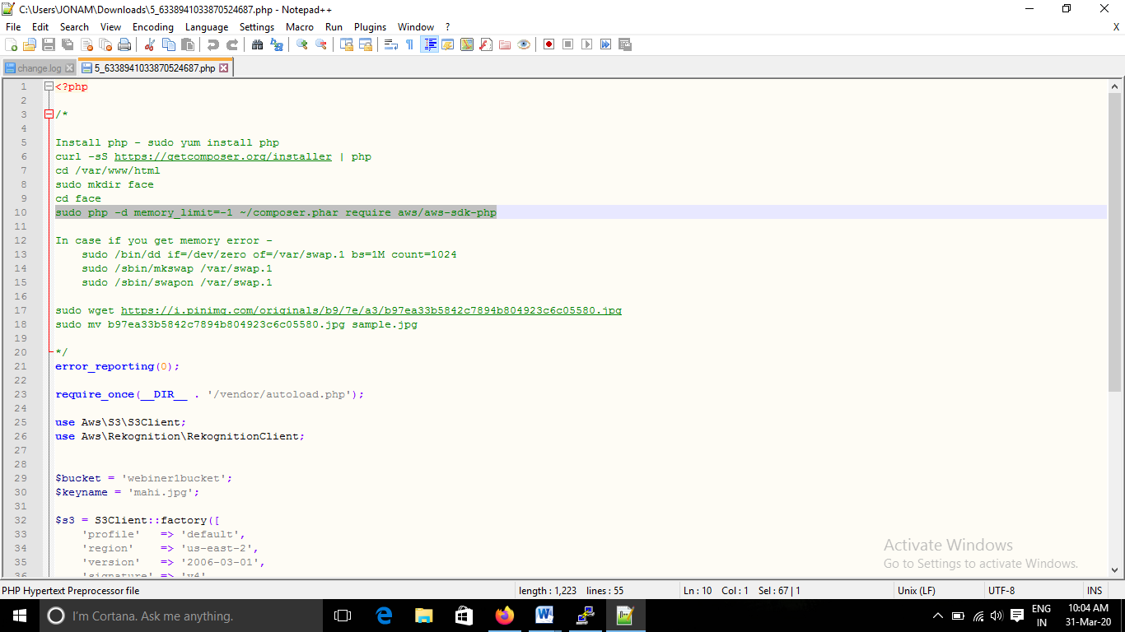

d. upload success screenshot



**6. Ec2 & Rekognition**

Face detect success screenshot

